St Edburg’s Church
Bicester
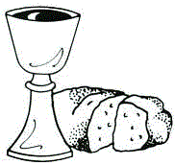
All Age
Holy Communion
Services at St Edburg’s, Bicester
& via Zoom
The Gathering
We stand as the ministers enter
Hymn/Song
The Greeting
We meet in the name of Almighty God, Father, Son and Holy Spirit.
All Amen.
Words of welcome may be said
Prayers of Penitence
Lord God, our maker and our redeemer,
this is your world and we are your people:
come among us and save us.
We have wilfully misused your gifts of creation;
Lord, be merciful:
All forgive us our sin.
We have seen the ill-treatment of others
and have not gone to their aid;
Lord, be merciful:
All forgive us our sin.
We have heard the good news of Christ,
but have failed to share it with others;
Lord, be merciful:
All forgive us our sin.
We have not loved you with all our heart,
nor our neighbours as ourselves;
Lord, be merciful:
All forgive us our sin.
Absolution
May almighty God have mercy on you, forgive you your sins, and bring you to everlasting life, through Jesus Christ our Lord.
All Amen.
Peruvian Gloria
Glory to God, glory to God,
glory to the Father.
Glory to God, glory to God,
glory to the Father.
To him be glory forever.
To him be glory forever.
Alleluia, amen.
Alleluia, amen,
alleluia amen,
alleluia amen.
Glory to God, glory to God,
Son of the Father.
Glory to God, glory to God,
Son of the Father.
To him be glory forever.
To him be glory forever.
Alleluia, amen.
Alleluia, amen,
alleluia amen,
alleluia amen.
Glory to God, glory to God,
glory to the Spirit.
Glory to God, glory to God,
glory to the Spirit.
To him be glory forever.
To him be glory forever.
Alleluia, amen.
Alleluia, amen,
alleluia amen,
alleluia amen.
The Collect
The Collect is said
All Amen.
Hymn/Song
We remain standing for the Gospel
The Liturgy of the Word
Gospel Reading
Hear the Gospel of our Lord Jesus Christ according to N.
All Glory to you, O Lord.
At the end the reader says
This is the Gospel of the Lord.
All Praise to you, O Christ.

Address
Please sit
The Creed
Do you believe and trust in God the Father,
source of all being and life,
the one for whom we exist?
All We believe and trust in him.
Do you believe and trust in God the Son,
who took our human nature,
died for us and rose again?
All We believe and trust in him.
Do you believe and trust in God the Holy Spirit,
who gives life to the people of God
and makes Christ known in the world?
All We believe and trust in him.
This is the faith of the Church.
All This is our faith.
We believe and trust in one God,
Father, Son and Holy Spirit.
Amen.
Prayers

These responses may be used
Lord, in your mercy
All hear our prayer.
Or
Lord, hear us
All Lord, graciously hear us.
And at the end
Merciful Father,
All accept these prayers
for the sake of your Son,
our Saviour Jesus Christ.
Amen.
The Liturgy of the Sacrament
We stand
The Peace
God is love and those who live in love live in God and God lives in them.
The peace of the Lord be always with you
All and also with you.
Hymn/Song
A collection may be taken.
Preparation of the Table
With this bread that we bring
All we shall remember Jesus.
With this wine that we bring
All we shall remember Jesus.
Bread for his body,
wine for his blood,
gifts from God to his table we bring.
All We shall remember Jesus.
The Eucharistic Prayer
The Lord be with you
All and also with you.
Lift up your hearts.
All We lift them to the Lord.
Let us give thanks to the Lord our God.
All It is right to give thanks and praise.
It is right to praise you, Father, Lord of all creation;
in your love you made us for yourself.
When we turned away you did not reject us,
but came to meet us in your Son.
All You embraced us as your children
and welcomed us to sit and eat with you.
In Christ you shared our life
that we might live in him and he in us.
All He opened his arms of love upon the cross
and made for all the perfect sacrifice for sin.
On the night he was betrayed,
at supper with his friends
he took bread, and gave you thanks;
he broke it and gave it to them, saying:
Take, eat; this is my body which is given for you;
do this in remembrance of me.
All Father, we do this in remembrance of him:
his body is the bread of life.
At the end of supper, taking the cup of wine,
he gave you thanks, and said:
Drink this, all of you; this is my blood of the new covenant,
which is shed for you for the forgiveness of sins;
do this in remembrance of me.
All Father, we do this in remembrance of him:
his blood is shed for all.
As we proclaim his death and celebrate his rising in glory,
send your Holy Spirit that this bread and this wine
may be to us the body and blood of your dear Son.
All As we eat and drink these holy gifts
make us one in Christ, our risen Lord.
With your whole Church throughout the world
we offer you this sacrifice of praise
and lift our voice to join the eternal song of heaven:
All Holy, holy, holy Lord,
God of power and might,
Heaven and earth are full of your glory.
Hosanna in the highest.

The Lord’s Prayer
We join together in the words that Jesus himself taught us.
All Our Father in heaven,
hallowed be your name;
your kingdom come;
your will be done;
on earth as in heaven.
Give us today our daily bread.
Forgive us our sins,
as we forgive those who sin against us.
Lead us not into temptation;
but deliver us from evil.
For the kingdom,
the power and the glory are yours
now and for ever.
Amen.
Breaking of the Bread
We break this bread
to share in the body of Christ.
All Though we are many, we are one body,
because we all share in one bread.
Giving of Communion
God’s holy gifts for God’s holy people
All Jesus Christ is holy,
Jesus Christ is Lord,
to the glory of God the Father.
The president and people receive communion.
The Church of England welcomes anyone from any Christian Church who receives communion to receive it here.
We welcome people of all ages and beliefs to come up to the altar to receive a blessing, please bring a service booklet with you to indicate that this is your preference.
If you would prefer your wafer to be intincted (dipped in the wine) please indicate this to the priest.

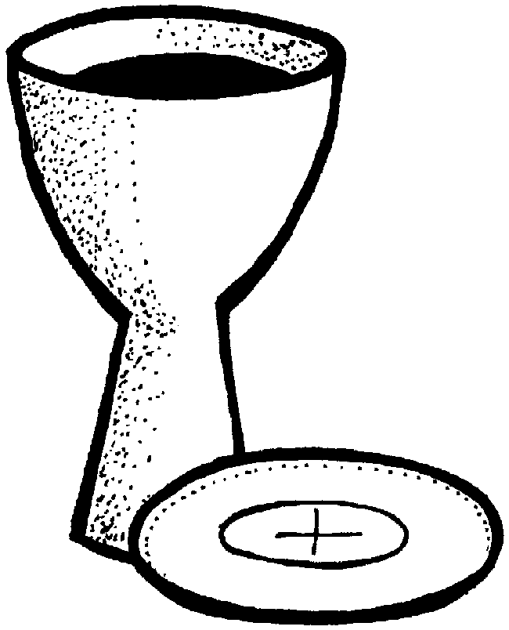
Prayer after communion
Silence is kept
All Christ leads us out, back into his world,
to live by his word, and to reflect his light and love,
to be his disciples in the days ahead.
Go with us always and guide us, good Lord.
Amen.
Notices
The Dismissal
We stand
The peace of God,
which passes all understanding,
keep your hearts and minds
in the knowledge and love of God,
and of his Son Jesus Christ our Lord;
and the blessing of God almighty,
the Father, the Son, and the Holy Spirit,
be among you and remain with you always.
All Amen.
Hymn/Song
Go in peace to love and serve the Lord.
All In the name of Christ. Amen.

Copyright acknowledgement (where not already indicated above):
Some material included in this service is copyright: © 1973, 1978, 1984 International Bible Society. Pub. Hodder & Stoughton
Some material included in this service is copyright: © The Archbishops' Council 2000
Collect (19th after Trinity) © The Archbishops' Council 2010
Compiled November 2024

